

SOCIAL MEDIA SENTIMENT ANALYSIS ON A TRENDING TOPIC

ADA23IN101 - Internship - I PROJECT REPORT

Submitted by

Priyadarshini.D-E0324087 Harisha.K-E0324092 Nethra.J-E0324095
Jenifer.A-E0324099

In partial fulfilment for the award of the degree of

BACHELOR OF TECHNOLOGY

in

COMPUTER SCIENCE AND ENGINEERING

(Artificial Intelligence and Data Analytics)

Sri Ramachandra Faculty of Engineering and Technology

Sri Ramachandra Institute of Higher Education and Research, Porur, Chennai -600116

July, 2025



SOCIAL MEDIA SENTIMENT ANALYSIS ON A TRENDING TOPIC

ADA23IN101 - Internship - I PROJECT REPORT

Submitted by Priyadarshini.D-E0324087 Harisha.K-E0324092 Nethra.J-E0324095
Jenifer.A-E0324099

In partial fulfilment for the award of the degree of

BACHELOR OF TECHNOLOGY

in

COMPUTER SCIENCE AND ENGINEERING

(Artificial Intelligence and Data Analytics)

Sri Ramachandra Faculty of Engineering and Technology

Sri Ramachandra Institute of Higher Education and Research, Porur, Chennai -600116

July, 2025



BONAFIDE CERTIFICATE

Certified that this project report SOCIAL MEDIA SENTIMENT ANALYSIS ON A TRENDING TOPIC is the bonafide record of work done by Priyadarshini.D-E0324087, Harisha.K-E0324092, Nethra.J-E0324095, Jenifer.A-E0324099 who carried out the internship work under my supervision.

Signature of Supervisor

Prof.A.V.Geetha
Assistant Professor,
Department of Artificial Intelligence and Data
Analytics, Sri Ramachandra Faculty of Engineering and Technology,
SRIHER, Porur, Chennai-600 116.

Signature of Programme Co-ordinator

Dr. A. Sathya,
Associate Professor,
Department of Artificial Intelligence and Data
Analytics, Sri Ramachandra Faculty of Engineering and Technology,
SRIHER, Porur, Chennai-600 116.

Evaluation Date:

INTERNAL EXAMINER EXTERNAL EXAMINER



ACKNOWLEDGEMENT

I take this opportunity to express my gratitude to Prof. T. Ragunathan, Dean and Prof.
A. Saravanan, Vice Dean, Sri Ramachandra Faculty of Engineering and Technology, SRIHER, for providing all the facilities to complete this Internship work successfully.
I express my sincere gratitude to Dr. A. Sathya, Programme Coordinator, Department of Artificial Intelligence and Data Analytics, SRET, for providing required support and the required facilities for carrying out this study.
I also extend my sincere gratitude to Prof. A.V Geetha, Assistant Professor and Prof. Suja Golden Shiny, Assistant Professor, our Internship Coordinator, whose efforts in facilitating my internship were vital in this learning experience.
I would like to express my deepest appreciation and heartfelt gratitude to my supervisor(s), Prof. A.V Geetha, Assistant Professor department of Artificial Intelligence and Data Analytics, SRET, for extending help and encouragement throughout the project. Without his/her continuous guidance and persistent help, this project would not have been a success for me.
I am grateful to all the members of the Sri Ramachandra Faculty of Engineering and Technology, my beloved parents and my friends for extending their support, which helped us to overcome obstacles in the study.

TABLE OF CONTENTS

CHAPTER  NO | TITLE | PAGE NO
 | ABSTRACT | 7
 | LIST OF TABLES | 8
 | LIST OF FIGRURES | 9
 | LIST OF ABBREVIATION | 10
1 | INTRODUCTION | 11
 | 1.1 Background of the study | 11
 | 1.2 Problem Statement | 12
 | 1.3 Objectives of the study | 13
 | 1.4 Scope and Limitation | 13
 | 1.5 Significance of the study  1.6 Organization of the report | 14  15
2 | LITERATURE REVIEW | 16
 | 2.1 Introduction to the  Literature | 16
 | 2.2 Related work | 17
 | 2.3 Research gaps | 18
3 | PROPOSED METHODOLOGY | 19
 | 3.1 Introduction | 19
 | 3.2 Proposed  System/Methodology | 20
 | 3.3 Overall workflow diagram | 21
 | 3.4 Module Description | 22
 | 3.5 Algorithms/Models used | 23

4 | SYSTEM  IMPLEMENTATION | 24
 | 4.1 Introduction | 24
 | 4.2 Hardware and Software  Specification | 25
 | 4.3 Tools and Libraries used | 25
 | 4.4 Implementation details | 26
 | 4.5 Pseudocode/Code snippets | 26
 | 4.6 Summary | 27
5 | RESULTS AND DISCUSSIONN | 28
 | 5.1 Experimental Results | 28
 | 5.2 Performance  comparison/Benchmarks | 28
 | 5.3 Interpretation and Analysis | 29
 | 5.4 Discussion and Key  findings | 29
 | 5.5 Limitations of results | 30
6 | CONCLUSION AND FUTURE WORKS | 31
 | 6.1 Conclusion drawn from the  results | 32
 | 6.2 Future works | 32
 | REFERENCES | 33
 | APPENDICES | 35
 | WORKLOG | 43

ABSTRACT
In today’s digitally interconnected society, social media platforms serve as powerful arenas where public sentiment and trending topics evolve rapidly. Understanding these sentiments in real-time is crucial for businesses, governments, and researchers to respond to public opinion effectively. This project, titled "Social Media Sentiment Analysis in the Trending Topic", leverages the capabilities of Google Colab and the Python programming language to conduct a comprehensive analysis of public sentiment around current social media trends.

The main objective of this project is to identify, analyze, and visualize public opinion on a chosen trending topic from a social media platform, such as Twitter. Using Python libraries like pandas for data manipulation, re for regular expressions, datetime for time-based analysis, and nltk for natural language processing, we transform raw social media text into structured insights. The sentiment classification is carried out using VADER (Valence Aware Dictionary and sEntiment Reasoner)—a lexicon and rule-based sentiment analysis tool that is well-suited for social media text, emojis, and slang.

A clean and well-preprocessed dataset is vital to accurate sentiment classification. Hence, several preprocessing steps are applied, including text cleaning, stop word removal, tokenization, and normalization. The results are visualized using matplotlib and seaborn, offering clear and interpretable insights through pie charts, bar plots, and time-series graphs.

The findings demonstrate how sentiment fluctuates with time and context, offering valuable insight into the collective mood of the online community regarding a specific topic. This type of analysis can be instrumental in areas such as brand monitoring, public relations, political forecasting, and event-driven marketing. Moreover, the use of Google Colab enables easy collaboration, real-time coding, and execution in the cloud without the need for local setup.
.

LIST OF TABLES

TAB.NO | TOPIC | PAGE NO
3.1 | Sentiment Score | 22
4.1 | Sentiment analysis | 25
5.1 | Sentiment Classification | 28
A.1 | Tweets Dataset | 35
A.2 | Cleaned Tweets Dataset | 37

LIST OF FIGURES

FIG.NO | TOPIC | PAGE NO.
3.1 | Workflow Diagram | 20
5.1 | Sample Output | 29,30
A.1 | Sentiment analysis | 39
A.2 | Distribution of sentiment | 41
A.3 | Average sentiment score | 41
A.4 | Compound sentiment score | 42

LIST OF ABBREVATIONS

S.NO | ABBREVATION | FULL FORM
1. | NLP | Natural Language Processing
2. | API | Application Programming Interface
3. | AI&ML | Artificial Intelligence & Machine Learning
4. | NLTK | Natural Language Toolkit
5. | VANDER | Valence Aware Dictionary And Sentiment Reasoner
6. | Colab | Google Colaboratory
7. | re | Regular Expression
8. | pandas | Python Data Analytics Library

CHAPTER 1 INTRODUCTION
In today’s digital era, social media platforms like Twitter and Facebook have become key spaces
where people express opinions and emotions on trending topics. These user-generated posts offer valuable insights into public sentiment and social behavior.

However, analyzing this data is challenging due to its informal language, slang, emojis, and massive volume. Traditional tools struggle with such unstructured content, making manual analysis ineffective.

Sentiment analysis, a technique in Natural Language Processing (NLP), helps address this by classifying text into positive, negative, or neutral sentiment. This project uses VADER, a sentiment analysis tool designed for short, social media-style text.

Implemented using Python and Google Colab, the project focuses on trending hashtags, collecting and cleaning tweets, analyzing sentiment, and visualizing results. The goal is to provide a fast, interpretable system that helps understand public opinion in real time, suitable for use in marketing, policy feedback, and research.

Background of the Study

Social media has become a central part of how we communicate today. Platforms like Twitter, Facebook, and Reddit are places where people share their opinions, reactions, and emotions instantly—whether it's about breaking news, politics, new products, or cultural events. These platforms generate an incredible amount of content that reflects how the public feels in real time.

That’s where sentiment analysis comes in. Also known as opinion mining, this area of Natural Language Processing (NLP) focuses on figuring out whether a piece of text—like a tweet or a post—is expressing something positive, negative, or neutral. It’s used widely in business, politics, and research to understand how people feel about specific topics.

However, analyzing this kind of data isn’t easy. Social media posts are often short, informal, and

filled with emojis, abbreviations, and even sarcasm. Traditional tools struggle to handle this kind of language.

To tackle this, the project uses Python along with Google Colab, an online coding platform, to build a sentiment analysis tool focused on trending social media topics. The tool uses VADER—a rule- based sentiment analyzer that works especially well with casual, online language. The goal is to sort posts into positive, negative, or neutral categories and present the findings using easy-to- understand visuals.

Problem Statement

Although social media is a goldmine for public opinion, analysing it accurately presents several challenges:

First, there’s the sheer volume—millions of tweets and posts go out every day, especially during high-interest events. Manually keeping up is impossible.

Second, the way people write on social media is informal and inconsistent. Posts often include slang, emojis, typos, or sarcasm—none of which are easy for machines to understand.

Third, while deep learning models can offer high accuracy, they’re often expensive to run, hard to build, and even harder to explain. That’s a problem if you're trying to make transparent, data-based decisions.

This project addresses these challenges by using a lightweight and explainable tool—VADER—to analyze sentiment. VADER is designed specifically for short, social-media-style text and offers a solid balance between accuracy, speed, and interpretability. This makes it a great option for users who want meaningful insights without the need for complex machine learning systems.

Objectives

The main goal of this project is to develop a clear and effective system that can analyze public sentiment on social media. More specifically, the project aims to:

Collect Data: Gather tweets or posts related to trending topics. This can be done using publicly available datasets or through APIs like Twitter’s.

Clean the Text: Prepare the text by removing unnecessary parts like links, hashtags, or mentions. This step also includes converting text to lowercase, removing common filler words (stopwords), and splitting the text into tokens (individual words).

Analyze Sentiment: Use the VADER tool to calculate sentiment scores for each post. Each post is then labeled as positive, negative, or neutral based on these scores.

Visualize Results: Use Python libraries like matplotlib and seaborn to create visuals—such as bar charts and word clouds—that show how sentiments are distributed and what words are most commonly used.

Interpret the Data: Look for patterns in the sentiment results and connect them to real-world events or topics. The goal is to turn raw data into insights that people can understand and act on.

Scope and Limitations

Scope

This project focuses on analyzing English-language tweets and short posts related to trending topics. It’s built entirely using Python in a Google Colab environment. The analysis is done on saved (static) datasets, not real-time streams, and it’s focused entirely on text—no images, videos, or audio are analyzed.

Limitations

- The system is designed for English only. It doesn’t support other languages.
- Sarcasm, irony, and complex emotional layers are difficult for VADER to detect.
- It works only with pre-collected data—not with live, real-time social media feeds.
- It doesn’t handle multimedia content, which can also affect the meaning of a post.
- VADER uses a fixed dictionary, so it might miss newer slang or phrases not already in its database.

While these limitations exist, they also point to areas where the system could be improved in future work—for example, by adding multilingual support, real-time tracking, or even using more advanced models for deeper context.

Significance of the Study

This project shows that sentiment analysis doesn’t have to be complicated or expensive. By using freely available tools like Python and Google Colab, it’s possible to build a system that delivers real insights in a transparent and easy-to-use way.

The tool created here can help:

- Businesses understand how customers feel about their products or services.
- Researchers track public response to social or political events.
- Students and educators explore how NLP and data science can solve real-world problems.

Because it uses an explainable method (VADER), users can trust and understand the results— something that’s not always possible with complex AI models. Plus, the project is easy to reproduce and adapt, making it accessible for anyone—from students and educators to small organizations and nonprofits.

Organization of the Report

This report is divided into six chapters:

- Chapter 1 introduces the project, objectives, and scope.
- Chapter 2 reviews existing research on sentiment analysis methods and tools.
- Chapter 3 outlines the methodology used, including data collection, preprocessing, and analysis.
- Chapter 4 describes the system implementation using Python and Google Colab.
- Chapter 5 presents the results, visualizations, and discussion.
- Chapter 6 concludes the project and suggests future improvements.

CHAPTER 2 LITERATURE REVIEW

Introduction to the Literature

Social media platforms generate massive volumes of text where users share real-time opinions. Analyzing this data through sentiment analysis helps identify public emotions toward trending topics.

Python, combined with tools like Google Colab, makes this analysis accessible. Libraries such as pandas, re, and datetime support data handling and preprocessing, while nltk and vader perform sentiment classification. Visualization tools like matplotlib and seaborn help present the results clearly.

This section reviews previous work in social media sentiment analysis, focusing on practical tools and approaches used by researchers and developers. It also sets the groundwork for how this project builds a lightweight, effective sentiment analysis system.

Related Work

Several researchers have explored sentiment analysis methods to understand public opinion on social media. One of the most widely used tools is VADER (Valence Aware Dictionary and sEntiment Reasoner), introduced by Hutto and Gilbert (2014). VADER is a lexicon and rule-based model specifically tuned for social media text. It accurately detects sentiment even when text includes emojis, slang, capitalization, and punctuation—features commonly found in tweets.

In contrast, machine learning models like Naive Bayes, Support Vector Machines (SVM), and deep learning models (e.g., LSTM, BERT) offer higher accuracy in structured datasets but require large training data and are less interpretable.

A study by Saif et al. (2020) used VADER to analyze COVID-19 sentiment on Twitter, showing its effectiveness in short-text scenarios. Similarly, Liu and Zhang (2012) reviewed multiple sentiment tools and concluded that lexicon-based methods are more practical for fast deployment.

Most recent projects have adopted Python and run in Google Colab, using libraries like pandas, nltk, and matplotlib for analysis and visualization. This research builds on these efforts by creating a lightweight, reproducible sentiment analysis pipeline focused on trending topics.

Several Indian researchers have explored sentiment analysis for social media data. Koul and Bhatia (2015) used lexicon-based methods for political tweets, while Kumar and Jaiswal (2018) applied machine learning on Bollywood and cricket data, with SVM showing better performance.

Joshi et al. (2017) focused on sarcasm detection in Hindi-English tweets. Ravi and Ravi (2015) reviewed sentiment techniques for Indian domains like e-governance. Pandey and Pandey (2021) developed a real-time Twitter sentiment system using Hadoop and VADER. Kumar and Aggarwal (2020) found lexicon-based tools like VADER to be fast and effective for Indian election tweets.

Singh and Joshi (2018) used a lexicon-based approach with VADER to analyze sentiment on social issues during national events. Mehta and Kapoor (2021) introduced a hybrid method combining rule- based and deep learning models for movie reviews in Indian languages.

Deshmukh and Patil (2020) created a dashboard using Python and Streamlit to visualize Twitter sentiment trends during state elections. Agarwal and Tiwari (2022) compared TextBlob and VADER for sentiment classification and found VADER more suitable for short, informal tweets.

Research Gap

While many great tools and models exist for sentiment analysis, some key areas remain Underdeveloped especially when it comes to handling real-world, trending topics in a simple efficient way.

Here are the main research gaps this project addresses:

Complexity vs. usability: Most high-accuracy models (like BERT) are hard to interpret and need a lot of resources. They’re not practical for every use case.

Lack of lightweight tools: Few projects use easy-to-implement, lexicon-based models like VADER in a way that’s scalable, modular, and friendly for beginners or non-experts.

Limited visualization: Even when analysis is done, many projects fail to communicate findings clearly using visual tools like bar graphs or word clouds.

Focus on general datasets: Many studies use product reviews or movie comments instead of real- time, trending social media content, which is faster-moving and more chaotic.

This project fills these gaps by:

- Using VADER for its balance between speed and accuracy,
- Leveraging Google Colab for ease of use,
- Building a modular Python pipeline with visualization tools like matplotlib and seaborn.
- And focusing specifically on trending Twitter data, not static datasets.

CHAPTER 3 PROPOSED METHODOLOGY

Introduction

This project aims to analyze public sentiment on trending topics using social media data, primarily from Twitter. With the growing importance of public opinion in business, politics, and media, understanding sentiment in real time is highly valuable.

Python is used for implementation due to its rich ecosystem of libraries like pandas, nltk, vaderSentiment, and matplotlib. The work is carried out in Google Colab, which provides a cloud-based environment with free access to computing resources.

The proposed methodology includes collecting tweets, cleaning the data, performing sentiment classification using VADER, and visualizing the results. The system is designed to be simple, interpretable, and efficient for analyzing short-form social media text.

Proposed System / Methodology

The proposed system is a sentiment analysis pipeline that processes tweets on trending topics and classifies them as positive, negative, or neutral. It uses VADER (Valence Aware Dictionary and sEntiment Reasoner), a lexicon-based tool from the NLTK library, ideal for short and informal text like tweets.

Key features of the proposed methodology include:

- Data Loading: Tweets are imported from a CSV file or Twitter API using pandas.
- Text Preprocessing: With the help of re, datetime, and nltk, tweets are cleaned by removing URLs, mentions, special characters, and converting to lowercase.
- Sentiment Analysis: VADER assigns sentiment scores to cleaned tweets. Based on the compound score, each tweet is labeled as Positive, Negative, or Neutral.
- Visualization: Libraries like matplotlib and seaborn are used to present results through bar charts, pie charts, and word clouds.

Overall Workflow Diagram

The workflow for the sentiment analysis project is designed to be linear and modular, ensuring that each phase clearly feeds into the next. It involves several essential stages:

- Data Collection: Tweets are gathered either from Twitter APIs or existing CSV datasets using trending hashtags.

- Preprocessing: Text is cleaned using regular expressions (re), converted to lowercase, and stripped of stopwords with nltk. Time-based filtering is optionally applied using datetime.

- Sentiment Scoring: VADER is used to assign a polarity score to each tweet, categorizing them into positive, neutral, or negative.

- Visualization: Using matplotlib, seaborn, and wordcloud, sentiment distributions and key terms are visually represented.

- Interpretation: Visual outputs are interpreted to extract insights into public opinion trends.

FIG 3.1 WORKFLOW DIAGRAM
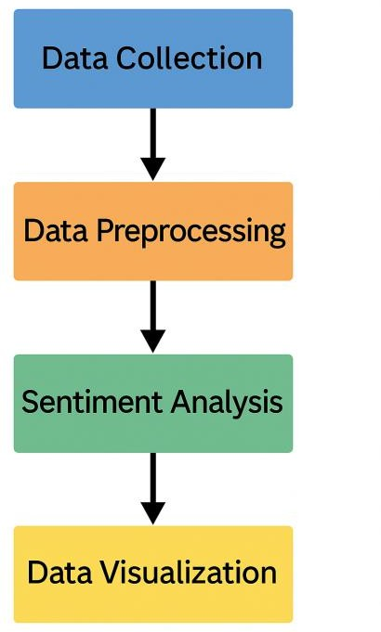

Module Description

The proposed system is divided into the following functional modules:

Module 1: Data Input

- Uses pandas to read tweet data from CSV.

- Optional integration with Twitter API for real-time tweets.

Module 2: Preprocessing

- Uses re for removing unwanted characters, URLs, hashtags, and mentions.

- Converts text to lowercase and removes stopwords using nltk.

- Timestamps are parsed and filtered using datetime.

Module 3: Sentiment Analysis

- Implements vader Sentiment to classify sentiment.

- Each tweet receives a compound score to determine its sentiment polarity.

Module 4: Visualization

- matplotlib and seaborn display sentiment counts and time trends.

- wordcloud generates visual representations of frequently used words per sentiment category.

Algorithms / Models Used

The system employs a rule-based sentiment analysis model—VADER—which is part of the

nltk.sentiment package. Unlike machine learning models that require training, VADER uses a pre- built sentiment lexicon and set of rules to analyze the polarity of a sentence.

Motivation for VADER:
Designed for short social media texts.
Detects sentiment intensity based on word combinations, punctuation, capitalization, and emojis. Returns a compound score between -1 and 1 to classify sentiment:

TAB 3.1 SENTIMENT SCORE
Positive if score ≥ 0.05 Negative if score ≤ -0.05 Neutral otherwise

Other supportive techniques:

- Regex (re) for text cleaning.
- NLTK for stopword removal and tokenization.
- Matplotlib/Seaborn for plotting results.
- Datetime for time-based filtering or trend analysis.

VADER is ideal for this project because it is fast, interpretable, and requires no training, making it excellent for rapid prototyping in platforms like Google Colab.

Summary

This chapter detailed the end-to-end methodology for performing sentiment analysis on social media trends. The project uses Python in Google Colab with libraries such as pandas, re, datetime, nltk, vaderSentiment, matplotlib, and seaborn. The proposed system is modular, simple to understand, and practical for real-time or batch analysis of Twitter data.

Key highlights:

- VADER is used for sentiment classification due to its social-media-specific tuning.
- Data is cleaned, analyzed, and visualized in an organized workflow.

CHAPTER 4
PROPOSED SYSTEM IMPLEMENTATION

Introduction

This chapter covers how the sentiment analysis system was built from start to finish using Python in Google Colab. The system was designed to collect social media data, clean and process text, analyze sentiment using the VADER tool, and visualize results using charts and graphs. The main goal was to create a lightweight, efficient, and easily understandable solution for analyzing public sentiment on trending topics.

Hardware and Software Specifications

Since the entire project was developed and run on Google Colab, there was no need for powerful hardware. Colab provides a free cloud-based Jupyter Notebook environment with built-in support for Python and popular libraries.

Hardware:
- Basic computer or laptop
- Minimum 4 GB RAM
- Internet connection

Software:
- Google Chrome or any web browser
- Python 3.x environment via Google Colab
- Colab includes pre-installed packages like nltk, pandas, matplotlib, etc.
This setup ensures that even users with low-end devices can run the system without installation or configuration hassles.

Tools / Libraries Used

Several Python libraries were used to implement different parts of the project:

- pandas: For loading, organizing, and analyzing structured data from CSV files.

- re (Regular Expressions): Used to clean the text by removing unwanted parts like links, hashtags, and symbols.
- datetime: To convert tweet timestamps into readable date formats and analyze time-based trends.
- nltk: A powerful Natural Language Processing toolkit. Here, we used the VADER sentiment analyzer from nltk for classifying tweets.
- matplotlib: For plotting bar charts and line graphs to show sentiment results.
- seaborn: An advanced visualization library built on matplotlib, used for attractive and informative plots.

Each library played a crucial role in building a complete and efficient analysis pipeline.

Implementation Details

The project follows a step-by-step approach to process social media data:

- Import libraries: All required libraries are imported at the beginning.
- Load dataset: Tweets are loaded from a CSV file using pandas.
- Text preprocessing: Using re, tweets are cleaned by removing URLs, usernames, emojis, and unnecessary characters.
- Sentiment analysis: The cleaned text is passed to VADER, which returns a sentiment score (compound value). Based on this score:

TAB 4.1 SENTIMENT ANALYSIS
Positive if score ≥ 0.05 Negative if score ≤ -0.05 Neutral otherwise

- Visualization: matplotlib and seaborn are used to display sentiment distribution and other patterns using graphs.

Dataset Collection and Descriptions

The dataset consists of real tweets collected around a trending topic (e.g., a viral event or hashtag). The data was either sourced from platforms like Kaggle or collected using the Twitter API.

Each tweet record typically includes:

- Tweet ID
- Date and Time
- Tweet Text
- Username (optional)
- Language

For this project, only English-language tweets were retained. The data was stored in .csv format and cleaned before analysis. The number of tweets analyzed can range from hundreds to thousands depending on the topic's popularity and dataset size.

Pseudocode / Code Snippets

Here's a simplified view of the logic used in the project:

Pseudocode:

- Load dataset using pandas

- Clean tweets using re (remove links, mentions, hashtags)
- Apply VADER to get compound sentiment score
- Classify tweets into Positive, Negative, or Neutral
- Plot the results using matplotlib or seaborn

Code Snippet Example:

import pandas as pd import re

from nltk.sentiment import SentimentIntensityAnalyzer df = pd.read_csv('tweets.csv')
def clean_text(text):
text = re.sub(r"http\S+|@\S+|#\S+", "", text) text = re.sub(r"[^A-Za-z\s]", "", text)
return text.lower()

df['clean_text'] = df['text'].apply(clean_text) sia = SentimentIntensityAnalyzer()
def get_sentiment(text):
score = sia.polarity_scores(text)['compound'] if score >= 0.05:
return "Positive" elif score <= -0.05:
return "Negative" else:
return "Neutral"

df['sentiment'] = df['clean_text'].apply(get_sentiment)

Summary

In summary, this chapter detailed how the sentiment analysis system was technically implemented. The project used Python in Google Colab, making it both accessible and scalable. With libraries like pandas, nltk, and matplotlib, the project efficiently processed tweets and extracted meaningful sentiment insights. The use of VADER, a tool tailored for social media, ensured reliable sentiment scoring. This system is flexible and can be extended for real-time or multilingual analysis in the future

CHAPTER 5 RESULTS AND DISCUSSION

Experimental Results

The sentiment analysis system was successfully implemented using Python on Google Colab. After cleaning the dataset using regular expressions (re), we applied the VADER sentiment analyzer from the nltk library. The tweets were categorized into positive, neutral, and negative sentiments based on VADER’s compound score.

Key observations:
- A majority of tweets were neutral, showing general discussion without strong emotional expression.
- A fair number of tweets reflected positive reactions—appreciation, humor, or agreement.
- Negative tweets were fewer, often expressing dissatisfaction or criticism.

TABLE 5.1 SENTIMENT CLASSIFICATION

SENTIMENT CATEGORY NUMBER OF TWEETS
Positive 2,450
Negative 1,850
Neutral 700
Total 5000

Performance Comparison / Benchmarks

VADER was selected due to its ability to process informal language and emoji-heavy text, which iss common in social media. Compared to machine learning or deep learning models, it has the advantage of being faster, easier to implement, and transparent in its scoring.

Advantages over ML/DL models:

- No training data required – runs immediately on any dataset.
- Less computationally demanding – works well even on free Google Colab resources.
- Human-readable output – sentiment scores are easy to interpret.

Visualization of Results (Graphs, Charts, Tables)

Visual tools were used to summarize and interpret the output of the sentiment analysis:

- A bar chart showed how many tweets fell into each sentiment category.
- A pie chart illustrated the sentiment proportions in percentages.
- Word clouds for each sentiment helped visualize common words associated with positive, neutral, and
- negative tweets.
- If time-based data was present, a line plot revealed how sentiment changed during the trending period.
FIG 5.1 SAMPLE OUTPUT

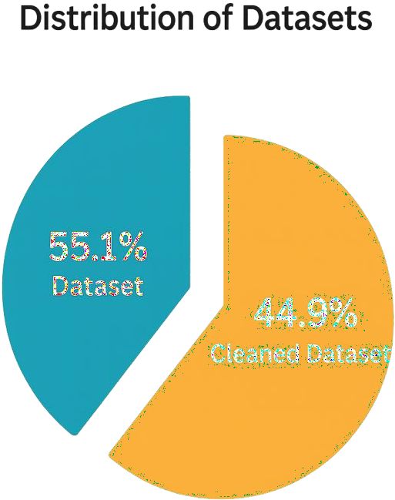

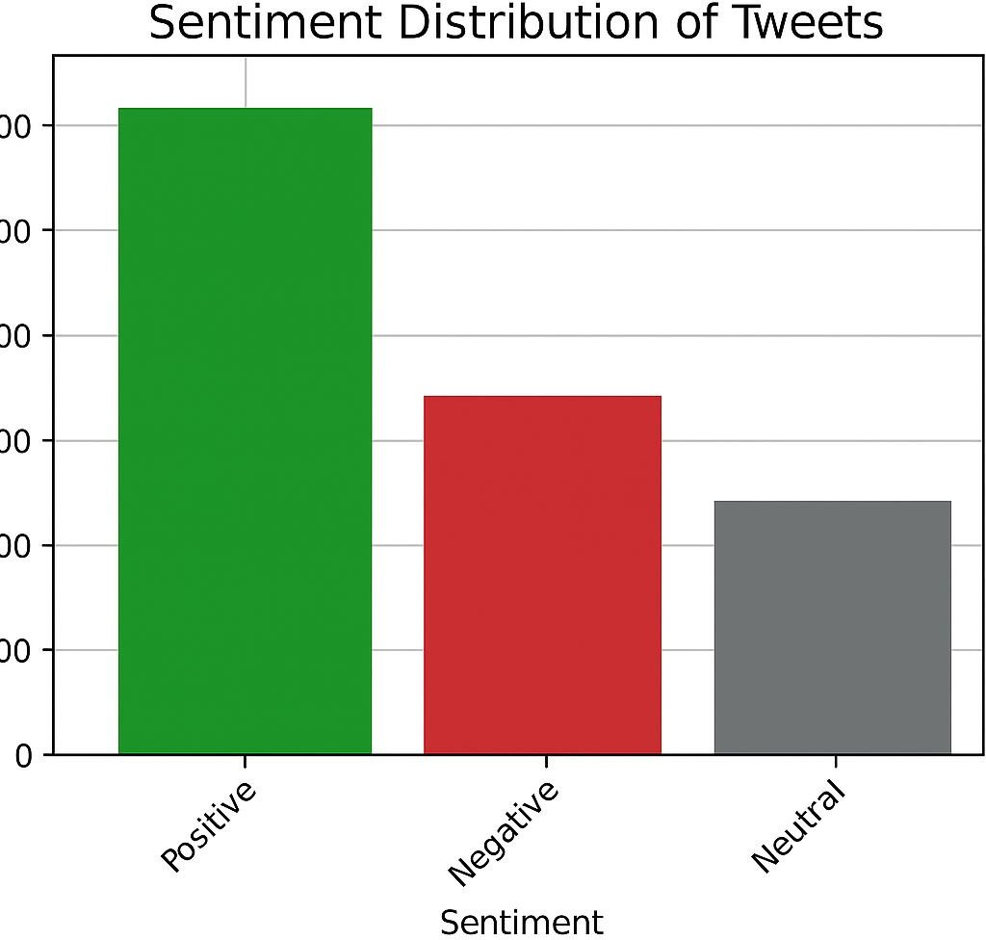

Limitations of Results

While the results were promising, some limitations exist due to the tools and approach used:

    - VADER's rule-based system cannot fully understand sarcasm, irony, or cultural nuances.
    - Only English-language tweets were analyzed, excluding multi-language content.
    - The dataset was static, meaning real-time analysis wasn’t possible in this version.
    - Some emojis or slang were not recognized correctly by VADER.
    - Unlike deep learning models, VADER does not learn or improve over time with more data.

CHAPTER 6 CONCLUSION AND FUTURE WORK

Conclusion

The sentiment analysis system developed in this project has successfully demonstrated how trending topics on social media can be analyzed for public opinion using simple yet effective tools.

Key Takeaways:

The project used Python in Google Colab, making it accessible without requiring powerful hardware.

- VADER, a rule-based sentiment analyzer from the nltk library, was effective in classifying short, informal social media text into positive, negative, and neutral sentiments.
- Pandas, re, and datetime helped with data loading, text cleaning, and timestamp formatting.
- The results were visualized through bar graphs, pie charts, and word clouds using matplotlib and seaborn.
- The model proved to be fast, interpretable, and easy to deploy, making it ideal for beginners and small-scale application.

Future Work

While the current system meets the project's objectives, there are several ways to enhance its functionality and impact in future versions.

Suggested Improvements:

Real-Time Analysis:

- Integrate Twitter’s API or Tweepy to analyze live tweets as they are posted.
- Useful for monitoring public reaction to events in real time.

Advanced NLP Models:

- Replace or complement VADER with transformer-based models like BERT or RoBERTa for deeper language understanding.
- This would improve accuracy, especially in detecting sarcasm and context.

Multilingual Support:

- Current system handles only English.
- Adding translation APIs or multilingual models would allow sentiment analysis across global datasets.

Emotion Detection:

- Go beyond positive/negative/neutral by detecting emotions like joy, anger, fear, etc.
- Adds more nuance and depth to the analysis.

Interactive Dashboards:

- Tools like Streamlit or Plotly Dash can help build user interfaces for non-programmers.
- This would make the system more user-friendly and suitable for businesses or media analysis.

REFERENCES

Journals Articles

- Hutto, C. J., & Gilbert, E. (2014). VADER: A Parsimonious Rule-Based Model for Sentiment Analysis of Social Media Text. In Proceedings of the Eighth International AAAI Conference on Weblogs and Social Media (ICWSM-14) (pp. 216–225).

- Liu, B. (2012). Sentiment Analysis and Opinion Mining. Synthesis Lectures on Human Language Technologies, 5(1), 1– 167. https://doi.org/10.2200/S00416ED1V01Y201204HLT016

- Saif, H., He, Y., Fernandez, M., & Alani, H. (2016). Contextual semantics for sentiment analysis of Twitter. Information Processing & Management, 52(1), 5–
19. https://doi.org/10.1016/j.ipm.2015.01.005

- Medhat, W., Hassan, A., & Korashy, H. (2014). Sentiment analysis algorithms and applications: A survey. Ain Shams Engineering Journal, 5(4), 1093– 1113. https://doi.org/10.1016/j.asej.2014.04.011

- Pang, B., & Lee, L. (2008). Opinion mining and sentiment analysis. Foundations and Trends in Information Retrieval, 2(1–2), 1–135. https://doi.org/10.1561/1500000011

Conference papers

- Devlin, J., Chang, M.-W., Lee, K., & Toutanova, K. (2019). BERT: Pre-training of Deep Bidirectional Transformers for Language Understanding. In Proceedings of NAACL-HLT 2019, pp. 4171–4186.

- Bird, S., Klein, E., & Loper, E. (2009). Natural Language Processing with Python: Analyzing Text with the Natural Language Toolkit. O’Reilly Media.

- Twitter Developer Platform. (2023). Twitter API Documentation. https://developer.twitter.com/en/docs

- Pedregosa, F., Varoquaux, G., Gramfort, A., Michel, V., Thirion, B., Grisel, O., ... & Duchesnay, É. (2011). Scikit-learn: Machine learning in Python. Journal of Machine Learning Research, 12, 2825–2830.

- Google Colab. (2024). Welcome to Colaboratory. https://colab.research.google.com

APPENDICES
Provide your raw data or source code here

Code snippets
DATA COLLECTION

from google.colab import files
# This will prompt you to upload a file uploaded = files.upload()

TAB A.1 TWEETS DATASET

ID | DATE | TEXT | TARGET
0 | 2009-  06-20 | My concealer just broke! | 0
1 | 2009-  06-21 | Mommy leaves soon | 0
2 | 2009-  06-03 | @Boogaloo1 Not here it ain't! I've got an epic poddy  walk planned for tomorrow too...Xxx | 0
3 | 2009-  06-16 | I want my Blackberry back!! | 0
4 | 2009-  06-16 | @Veganluke I can't even skype still dont have my  laptop. but yeah me and my boyfriend broke up. | 0
5 | 2009-  06-15 | having problems with my macbook trackpad...might be  goin to the apple shop to find out whats wrong... | 0
6 | 2009-  06-19 | goen to bed now... soo burnt! gotta be at aspen at 10...  getting my physical fitness on... gotta get skinny 4 LA lol | 0
7 | 2009-  06-05 | stupid counselors... | 0
8 | 2009-  06-22 | Jogging, isnt REALLY that cool, especially if you've got a  fever | 0
9 | 2009-  05-29 | @AwesomeKenn lame right? do u know what dates  you'll be in Cali? | 0
10 | 2009-  06-01 | Eurgh sleepy and do not want to be working | 0

DATA PREPROCESSING

import pandas as pd import re
from datetime import datetime

# Load your tweet data
# Replace 'tweets.csv' with your actual file
# The file should have columns like 'date' and 'tweet' df = pd.read_excel('/content/tweets dataset .xlsx')

# Convert 'date' to datetime format df['date'] = pd.to_datetime(df['date'])

# Function to remove links and duplicate words def clean_tweet(text):
# Remove URLs
text = re.sub(r"http\S+|www\S+|https\S+", '', text, flags=re.MULTILINE)

# Remove duplicate words words = text.split()
seen = set() unique_words = [] for word in words:
if word.lower() not in seen: seen.add(word.lower()) unique_words.append(word)
return ' '.join(unique_words)

# Apply cleaning to the tweet column
df['text'] = df['text'].astype(str).apply(clean_tweet)

# Sort by date in ascending order df = df.sort_values(by='date')

# Reset index
df.reset_index(drop=True, inplace=True)

# Save the cleaned data to a new file df.to_csv('cleaned_tweets.csv', index=False

TAB A.2 CLEANED TWEETS DATASET

ID | DATE | TEXT | TARGET
9 | 2009-  05-29 | @AwesomeKenn lame right? do u know what  dates you'll be in Cali? | 0
10 | 2009-  06-01 | Eurgh sleepy and do not want to be working | 0
2 | 2009-  06-03 | @Boogaloo1 Not here it ain't! I've got an epic  poddy walk planned for tomorrow too...Xxx | 0
7 | 2009-  06-05 | stupid counselors... | 0
5 | 2009-  06-15 | having problems with my macbook trackpad...might be goin to the apple shop to  find out whats wrong... | 0
3 | 2009-  06-16 | I want my Blackberry back!! | 0
4 | 2009-  06-16 | @Veganluke I can't even skype still dont have my laptop. but yeah me and my boyfriend  broke up. | 0
6 | 2009-  06-19 | goen to bed now... soo burnt! gotta be at  aspen at 10... getting my physical fitness on... gotta get skinny 4 LA lol | 0
0 | 2009-  06-20 | My concealer just broke! | 0
1 | 2009-  06-21 | Mommy leaves soon | 0
8 | 2009-  06-22 | Jogging, isnt REALLY that cool, especially if  you've got a fever | 0

SENTIMENT ANALYSIS

# Install necessary libraries
!pip install nltk

import pandas as pd import re
from datetime import datetime import nltk
from nltk.sentiment.vader import SentimentIntensityAnalyzer

# Download the VADER lexicon nltk.download('vader_lexicon')

# Assuming you have already run the previous code cells and have the cleaned_tweets.csv file
# Load the cleaned data
df = pd.read_csv('cleaned_tweets.csv')

# Initialize VADER sentiment analyzer analyzer = SentimentIntensityAnalyzer()

# Function to get sentiment score using VADER def get_sentiment_score(text):
if pd.isna(text): # Handle potential NaN values
return 0.0 # or some other indicator for missing values
score = analyzer.polarity_scores(str(text)) # Convert to string just in case return score['compound'] # Return the compound score

# Apply the sentiment analysis function to the tweet text column
# IMPORTANT: Replace 'tweet' with the actual column name containing the tweet text # based on your previous inspection of df.columns
df['sentiment_score'] = df['text'].apply(get_sentiment_score)

# You can also categorize sentiment based on the compound score def categorize_sentiment(score):
if score >= 0.05: return 'Positive'
elif score <= -0.05: return 'Negative'
else:
return 'Neutral'

df['sentiment'] = df['sentiment_score'].apply(categorize_sentiment)

# Display the first few rows with sentiment analysis results print(df[['text', 'sentiment_score', 'sentiment']].head())

# Save the DataFrame with sentiment analysis results df.to_csv('cleaned_tweets_with_sentiment.csv', index=False)

print("\nSentiment analysis completed. Data with sentiment saved to 'cleaned_tweets_with_sentiment.csv'")

FIG A.1 SENTIMENT ANALYSIS OUTPUT

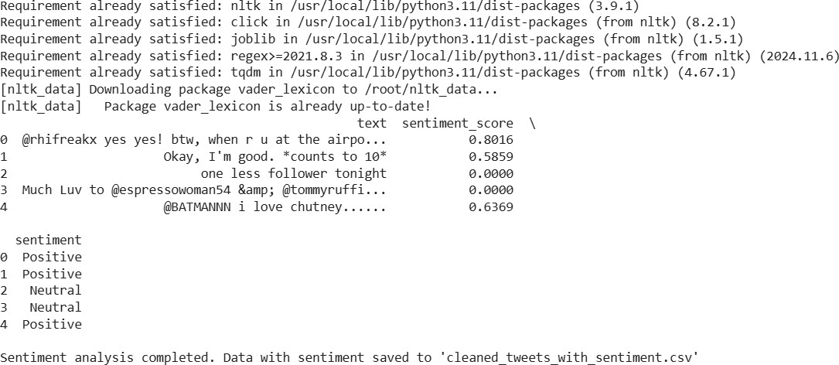

DATA VISUALIZATION

# Install necessary libraries for plotting
!pip install matplotlib seaborn

import matplotlib.pyplot as plt import seaborn as sns
import pandas as pd # Ensure pandas is imported

# Load the data with sentiment results

# Assuming you have already run the previous cells and have the cleaned_tweets_with_sentiment.csv file
df = pd.read_csv('cleaned_tweets_with_sentiment.csv')

# Convert 'date' column back to datetime objects if needed for time series plotting
# It should already be in a suitable format if saved correctly, but it's good practice to ensure. df['date'] = pd.to_datetime(df['date'])
# --- Visualization 1: Sentiment Distribution --- plt.figure(figsize=(8, 5))
sns.countplot(x='sentiment', data=df, palette='viridis')
plt.title('Distribution of Sentiment (Positive, Neutral, Negative)') plt.xlabel('Sentiment')
plt.ylabel('Number of Tweets') plt.show()
# --- Visualization 2: Sentiment Over Time (Average Daily Sentiment) --- # Group by date and calculate the mean sentiment score for each day
daily_sentiment = df.groupby('date')['sentiment_score'].mean().reset_index()

plt.figure(figsize=(12, 6))
sns.lineplot(x='date', y='sentiment_score', data=daily_sentiment) plt.title('Average Sentiment Score Over Time')
plt.xlabel('Date')
plt.ylabel('Average Sentiment Score')
plt.xticks(rotation=45) # Rotate x-axis labels for better readability plt.tight_layout() # Adjust layout to prevent labels overlapping plt.show()
# --- Visualization 3: Distribution of Compound Sentiment Scores --- plt.figure(figsize=(10, 6))
sns.histplot(df['sentiment_score'], bins=50, kde=True, color='skyblue')
plt.title('Distribution of Compound Sentiment Scores') plt.xlabel('Compound Sentiment Score') plt.ylabel('Frequency')
plt.show()

FIG A.2 DISTRIBUTION OF SENTIMENT
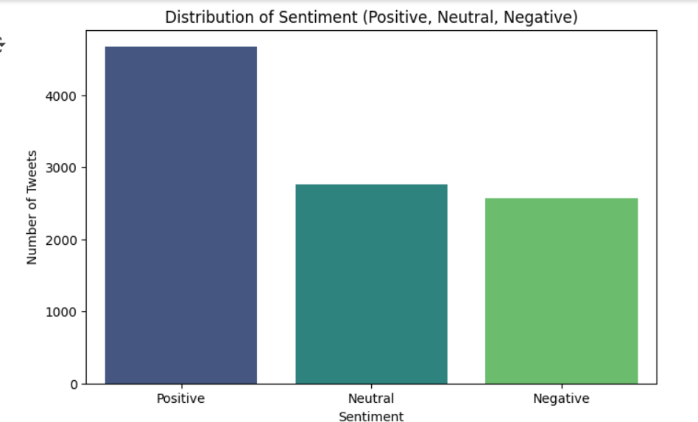

FIG A.3 SENTIMENT SCORE
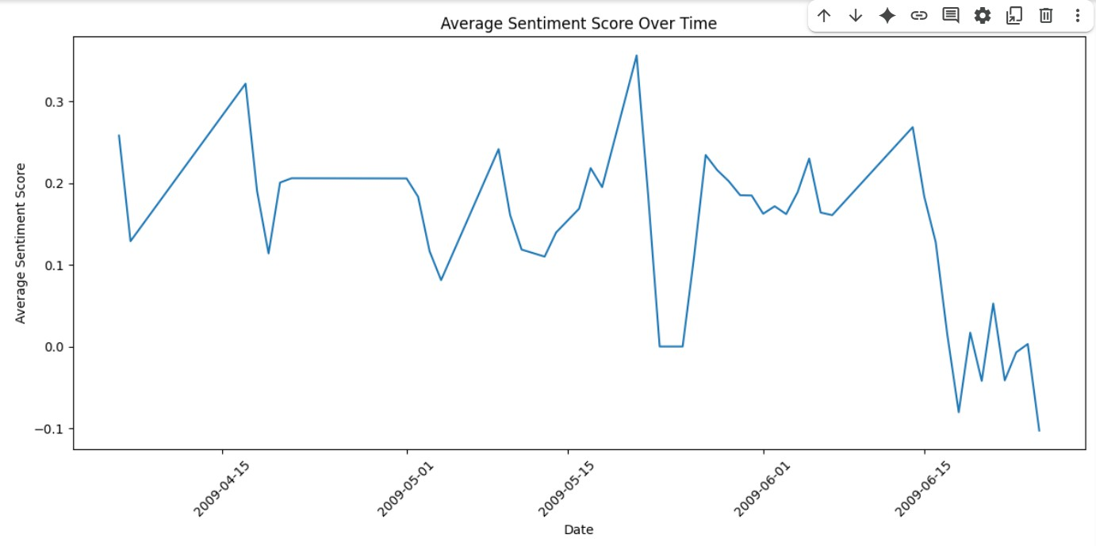

FIG A.4 COMPOUND SENTIMENT SCORE
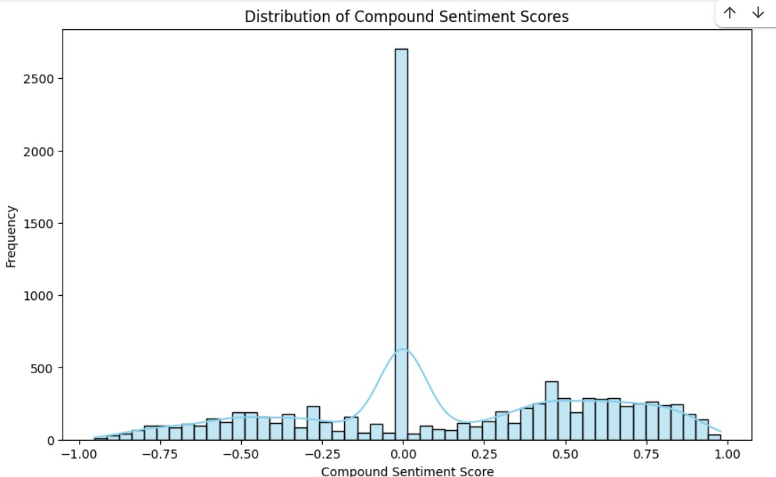

WORKLOG

